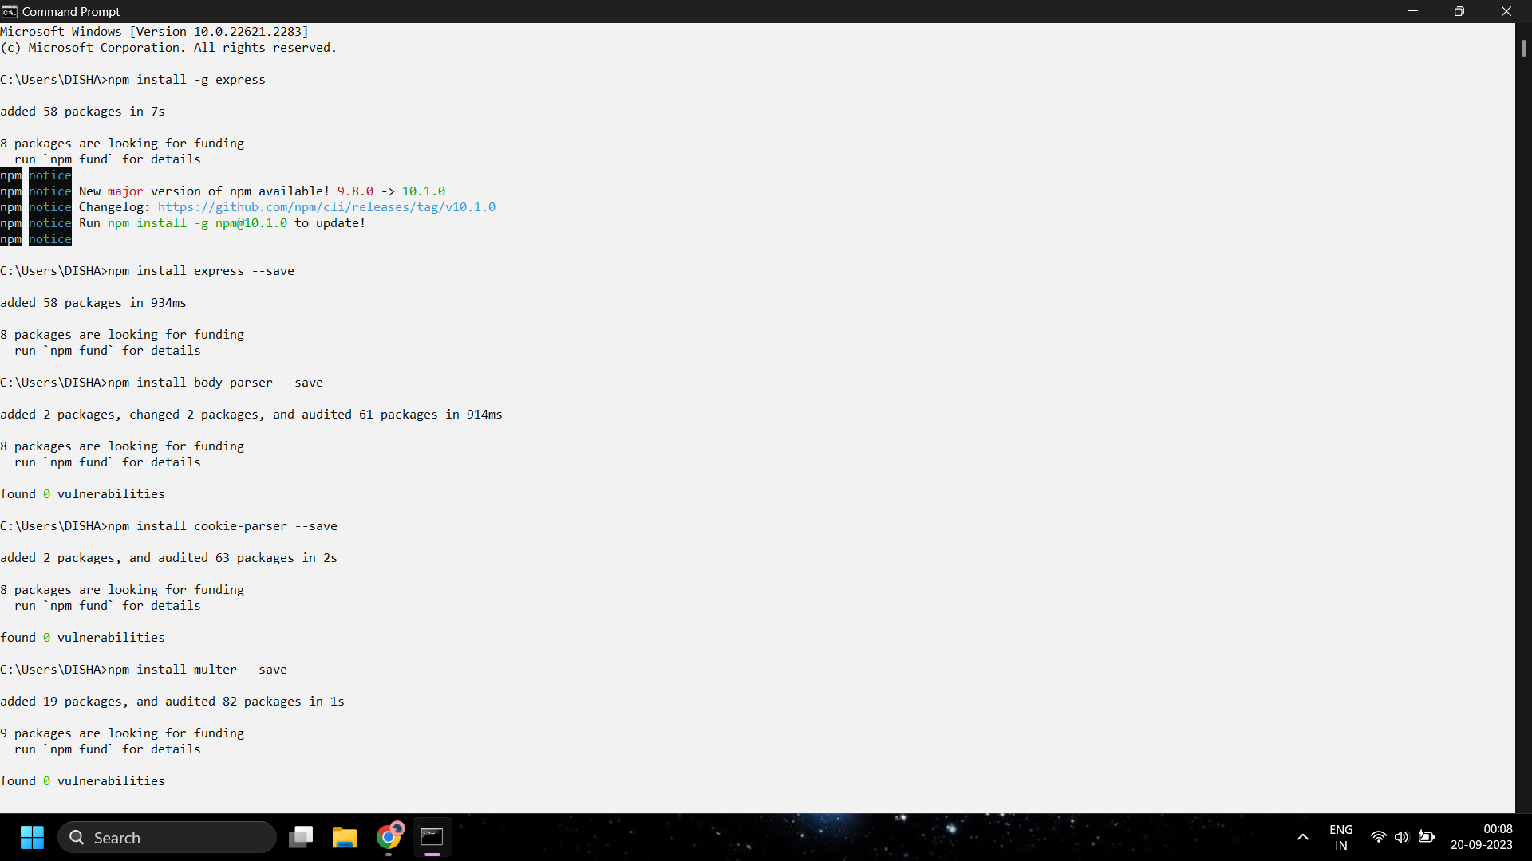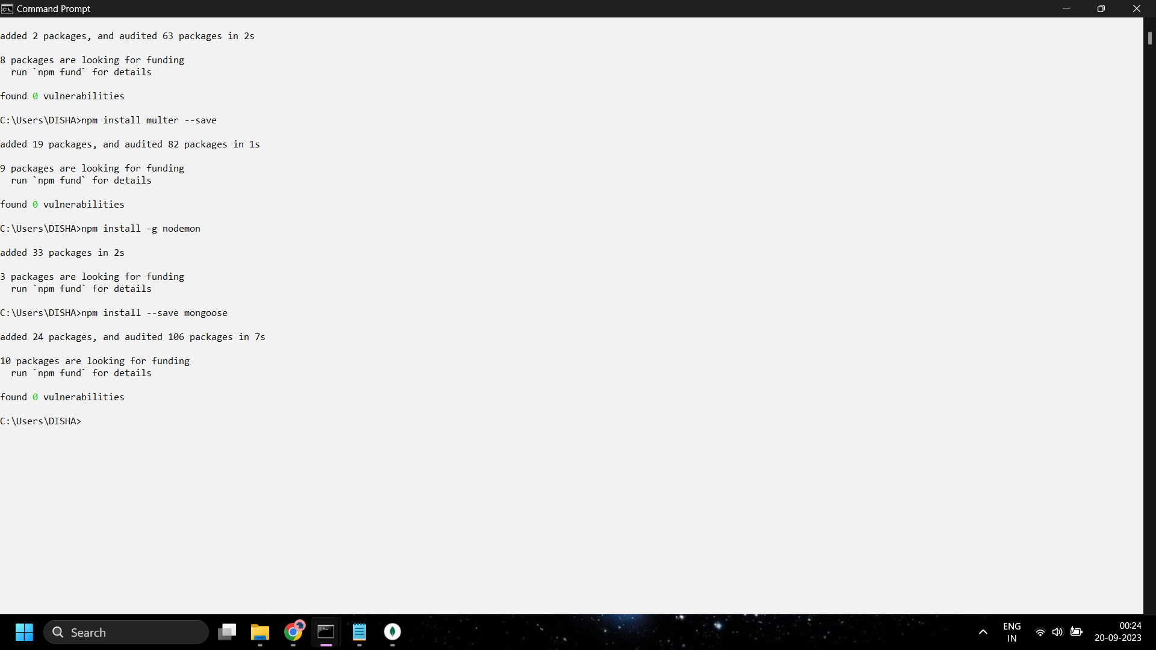

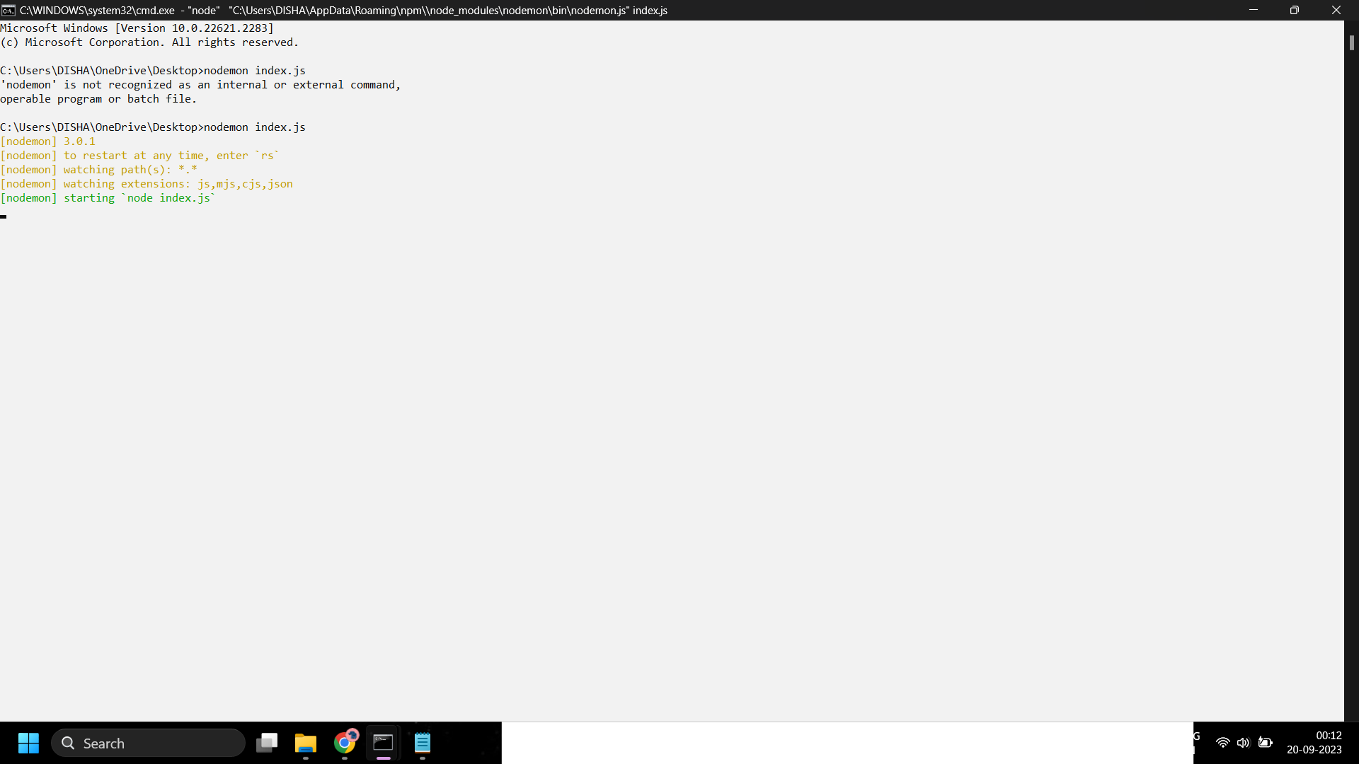

**CODE:**

var express = require('express');

var app = express();

app.get('/', function(req, res){

res.send("Hello world!");

});

app.listen(3000);

**OUTPUT:**

